**Homework 4 Answer Sheet for the Bonus Question**

Please state the name and SID of all members of your group.

|  |  |  |  |
| --- | --- | --- | --- |
| member | name | SID | email |
| #1 (contact person) | Ip wing kai | 58120400 | kaiwip3-c@my.cityu.edu.hk |
| #2 | LIN Weiyuan | 58537684 | weiyualin3-c@my.cityu.edu.hk |
| #3 | LEE Kin Wai | 57925345 | kwlee232-c@my.cityu.edu.hk |

1. Please graphically explain the part of circuits included in each step of the pipeline, and the registers forwarding information across different steps of the pipeline.

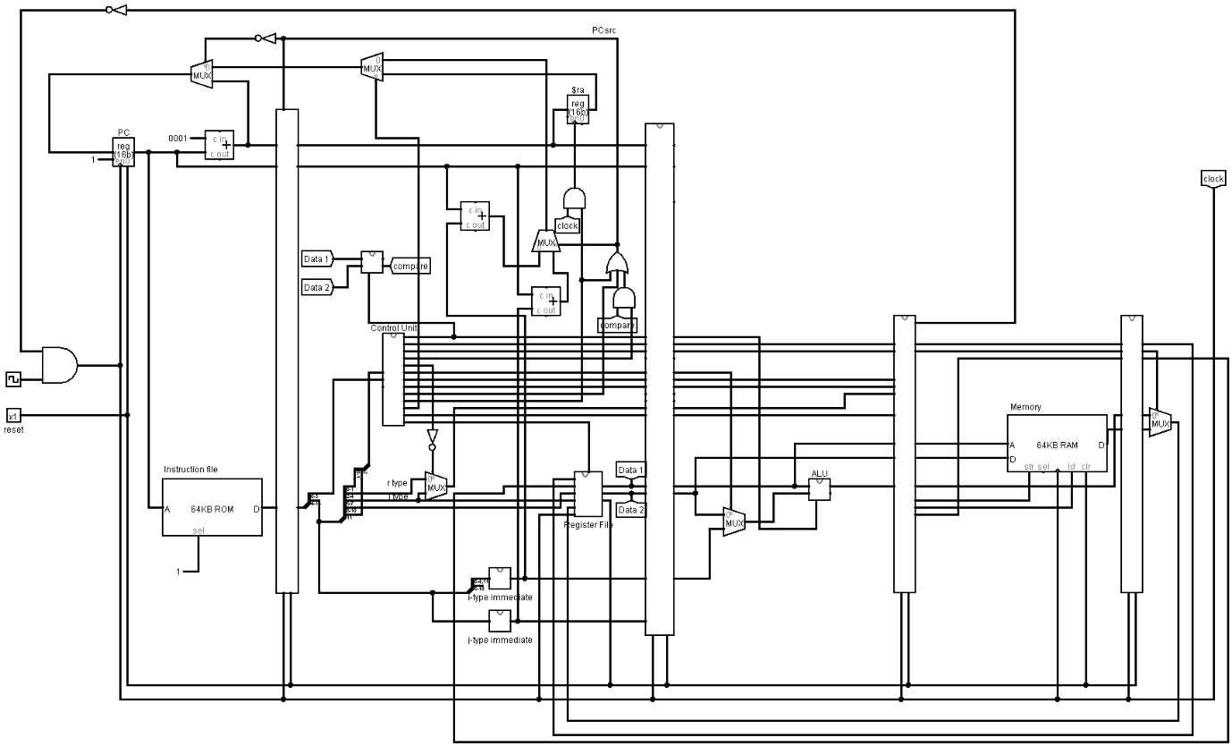

The graph shows the overall elements of the circuit. The circuit contains 4 bars and 5 areas separated by those bars. The main function of those bars is to transfer signal of each instruction, including control signals from control unit and data from register or ALU. The 5 stages in the pipelined circuit are instruction fetch stage, instruction decode stage, execution stage, memory access stage and write-back stage. Therefore, 4 instructions can be processed in the same tick.

1. Please explain how your processor deals with different types of hazards. Please include a detailed explanation about the extra circuits you added to the processor to resolve the hazards. Please also include detailed information about the test programs you used to test whether your program can correctly handle different types of hazards.

This program solve control hazards, by handling branch, jump, call, rtn, halt in stage 2. However, the line of code after branch, jump, call, rtn, should be the code that is not affected by that instruction, since there is an 1 cycle delay in stage 2, when the program check in stage 2, the next line of code is already in if/id.